University of Science and Technology
- Wrocław-



LABORATORY 10: UTILIZING SOFTWARE TO COMMUNICATE WITHIN A GROUP

SUPPORT FOR IT PROJECT MANAGEMENT
2025/2026
Teacher: Piotr Zabawa
Student: Álvaro Puebla Ruisánchez 293867

Table of Contents
Table of Contents 2
1. Software Overview 3
1.1 Name and Purpose 3
1.2 Key Functionality 3
1.3 Why Slack Was Selected 4
2. Performed Tasks 5
2.1 Task 1 - Workspace Setup and Channel Creation 5
2.2 Task 2 - Configuring the Channel: Canvas, Topic, Threaded Discussion 6
2.3 Task 3 - Automating Communication with Workflow Builder 8
3. Summary 9
3.1 Software Suitability Assessment 9
3.2 Evaluation of Software Functionality 9
3.3 User Interface Evaluation 9
3.4 Evaluation of Other Software Attributes 10

1. Software Overview

1.1 Name and Purpose
Slack is a cloud-based team communication and collaboration platform developed and maintained by Salesforce. Its primary purpose is to serve as a centralized hub for all project-related communication, enabling both real-time and asynchronous interaction among team members. In the context of IT project management, Slack addresses the need for a single source of truth for discussions, replacing fragmented communication channels such as email with a structured, searchable, and persistent messaging environment. From a Project Manager's perspective, the platform fulfills critical requirements including centralized knowledge management, transparent visibility into work progress without the overhead of intrusive status meetings, rapid contextual search over past decisions and technical specifications, and security mechanisms that ensure intellectual property remains within organizational boundaries.

1.2 Key Functionality
Slack provides a comprehensive set of functionalities organized around its core communication and workflow management capabilities. The platform's primary channel is Persistent Messaging, classified as a Must Have requirement, which accepts rich text input including emojis and code snippets, and produces a time-stamped, searchable message feed suitable for both real-time and asynchronous team synchronization. Complementing this is the Threaded Replies feature, also classified as Must Have, which allows users to reference a specific message and generate a nested conversation branch, thereby maintaining contextual clarity and reducing noise in the main channel. For more immediate communication needs, Slack offers Instant Huddles (classified as Should Have), which initiates low-latency audio and video conference sessions, enabling teams to resolve complex issues quickly through ad-hoc calls. At the workflow management level, Universal Search (Must Have) allows users to query all message history using keywords and filters such as sender or date, returning relevance-ranked results that ensure legacy knowledge is never lost. App Integrations (Could Have) extend this further by connecting external services via webhooks-such as Jira and GitHub-to produce automated alerts and actions directly within channels. Additional functionalities include User Identity Management via LDAP/SSO credentials for permission-based access and role governance (Must Have); File Version Control through cloud storage links for preview and direct editing, preventing data silos (Should Have); Notification Profiles driven by schedule and keyword rules delivering mobile and desktop alerts to support work-life balance (Should Have); and Interactive Canvases that accept free-form text and media to produce collaborative documents serving as permanent project documentation (Could Have).

1.3 Why Slack Was Selected
Following a comparative market analysis of the leading group communication solutions-including Microsoft Teams (included in Microsoft 365 at $4.00/user/month), Discord ($0 Free / $9.99 Nitro/user/month), and Rocket.Chat ($0 Community / $4.00 Pro/user/month)-Slack was selected as the software for this laboratory session for four principal reasons. First, Slack offers an unmatched integration ecosystem with over 2,600 applications available in its directory, enabling seamless PM workflow integration with tools already in use by development teams. Second, its superior user experience reduces cognitive load and drives higher team adoption rates while minimizing the risk of "shadow IT" arising from users seeking alternative, unauthorized tools. Third, Slack's search-first architectural philosophy ensures that all historical knowledge-including past decisions, technical discussions, and project specifications-remains permanently accessible and retrievable. Fourth, Slack provides full mobile parity, meaning that all core features are available on mobile devices without degradation, ensuring that distributed and remote teams maintain continuous connectivity. It is also worth noting that Slack offers a free tier suitable for evaluation purposes, as well as enterprise-grade pricing that includes SAML-based SSO, compliance exports, and 99.99% uptime guarantees for organizations in regulated industries.

2. Performed Tasks

2.1 Task 1 - Workspace Setup and Channel Creation
Task description:
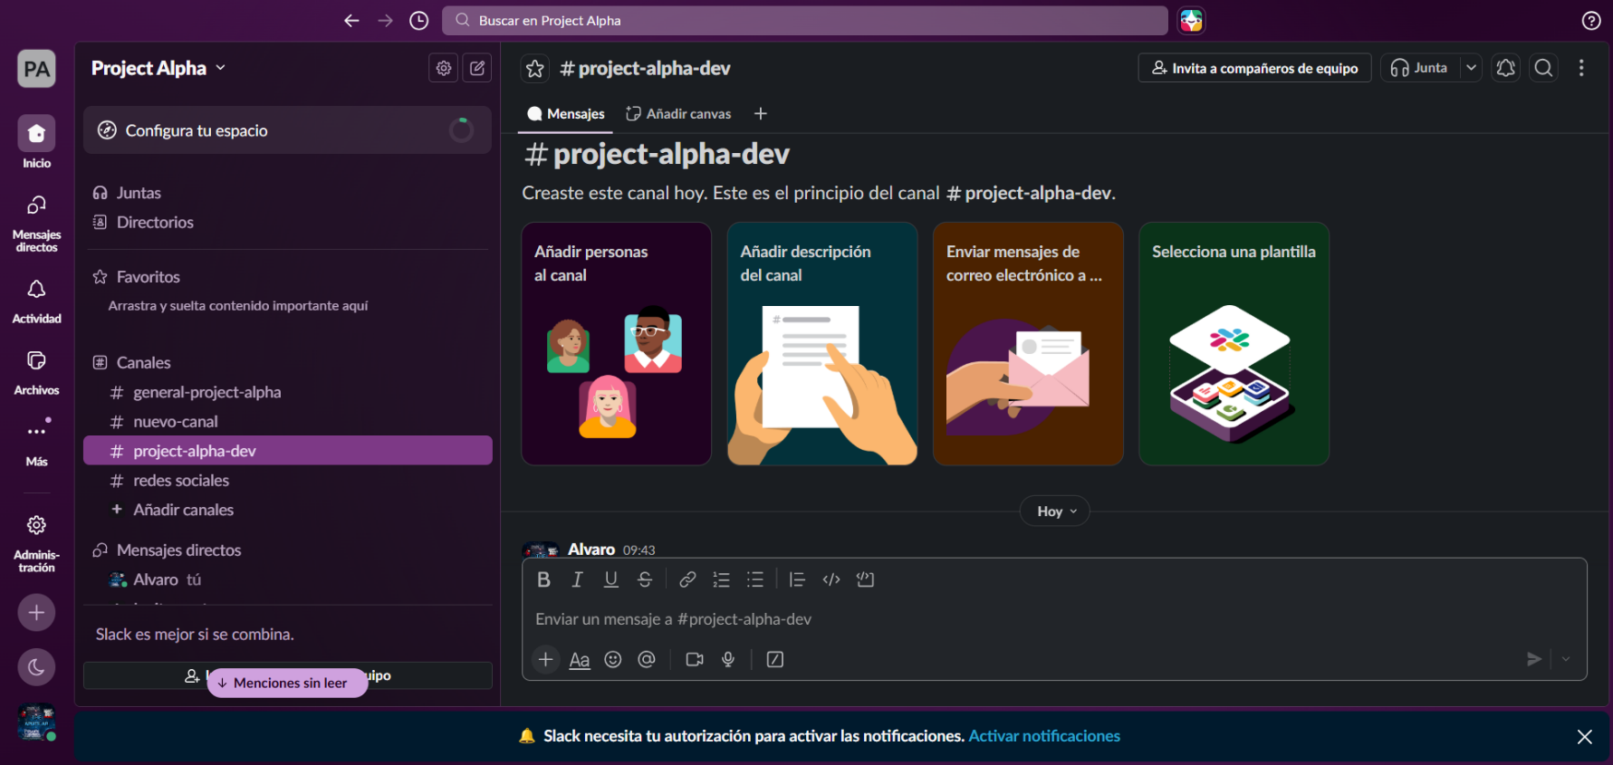
The first task involved the initial setup of a Slack workspace and the creation of a dedicated project channel. The process began by navigating to slack.com and selecting the "Create a Workspace" option. Authentication was performed using a Google account or email address, and the Slack Free (Limited) plan was chosen as the account tier. Once inside the newly created workspace, the task proceeded with the creation of a new public channel named #project-alpha-dev. This was accomplished by clicking the "Add channels" option in the left-hand sidebar, selecting "Create a new channel," entering the channel name as "project-alpha-dev," and confirming the creation. The channel was designed to serve as the primary communication space for a simulated software development project, providing a structured and persistent environment for all project-related discussions. This step established the foundational communication infrastructure upon which subsequent configuration tasks were built. [Figure 1]
Figure 1. Screenshot of the newly created #project-alpha-dev channel within the Slack workspace, showing the empty channel interface immediately after creation, including the channel name in the header and the default welcome message.

2.2 Task 2 - Configuring the Channel: Canvas, Topic, Threaded Discussion
Task description:
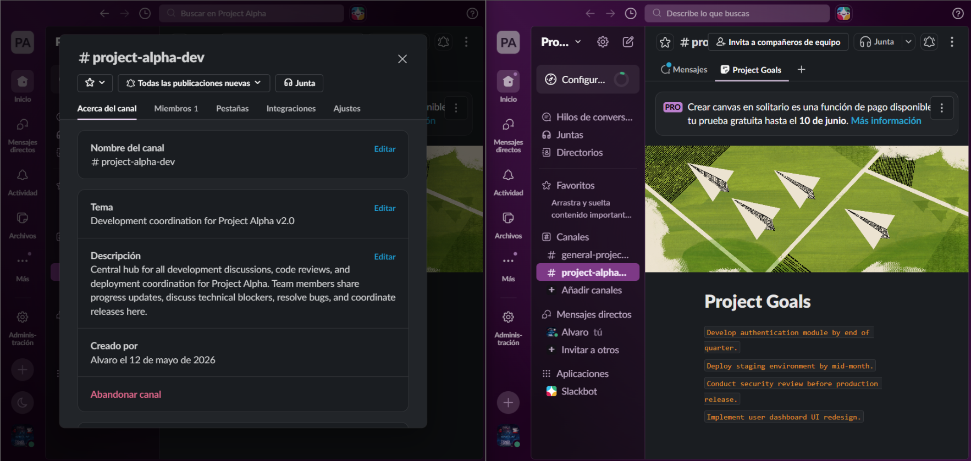
The second task focused on enriching the #project-alpha-dev channel with structured content and demonstrating the threaded messaging feature. The first sub-task was to add a Channel Canvas to the channel. This was done by clicking the Canvas icon located in the channel header toolbar, which opened an embedded collaborative document within the channel. Inside the Canvas, project goals were documented in free-form text, establishing a permanent, editable reference document visible to all channel members. The second sub-task involved setting a channel Topic and Description: the channel Topic was configured by clicking "Add a topic" in the channel header and entering a concise description of the channel's current focus, while the channel Description was set via the channel settings to provide a more detailed explanation of its purpose and intended audience. [Figure 2]
Figure 2. Screenshot showing the Channel Canvas populated with project goals, the channel Topic and Description are visible.

The third sub-task demonstrated Slack's threaded conversation capability by posting an initial message to the channel simulating a bug report-for example, a message stating that a critical login failure had been identified in the authentication module. A thread was then initiated on that message by clicking "Reply in thread," and one or more follow-up replies were added within the thread to simulate a contextual technical discussion, illustrating how threaded replies keep complex issue discussions contained without cluttering the main channel feed. [Figure 3]
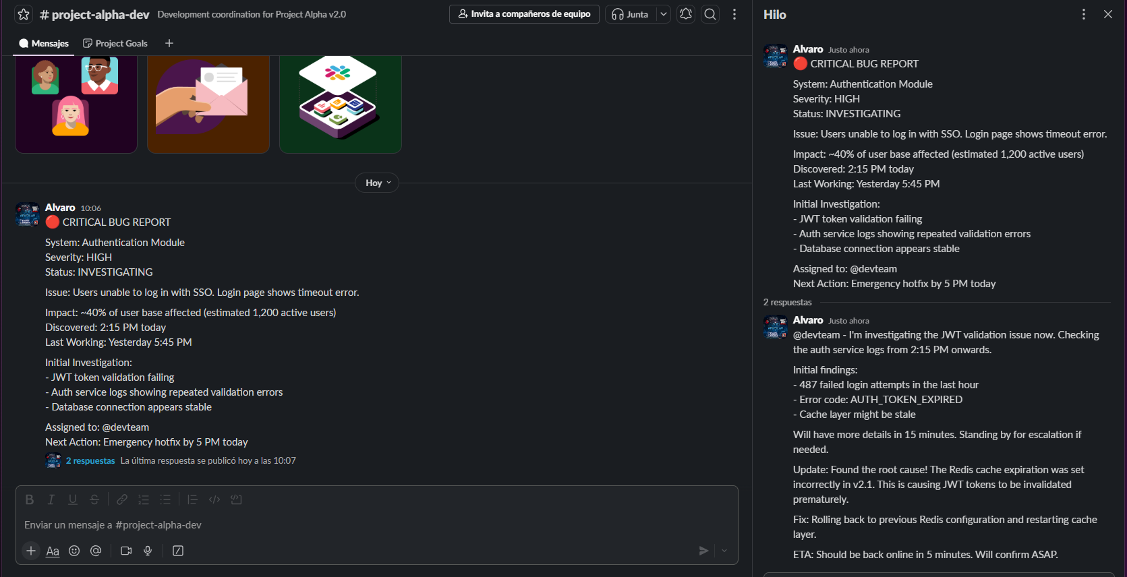
Figure 3. Screenshot showing a simulated thread of a bug report.

2.3 Task 3 - Automating Communication with Workflow Builder
Task description:
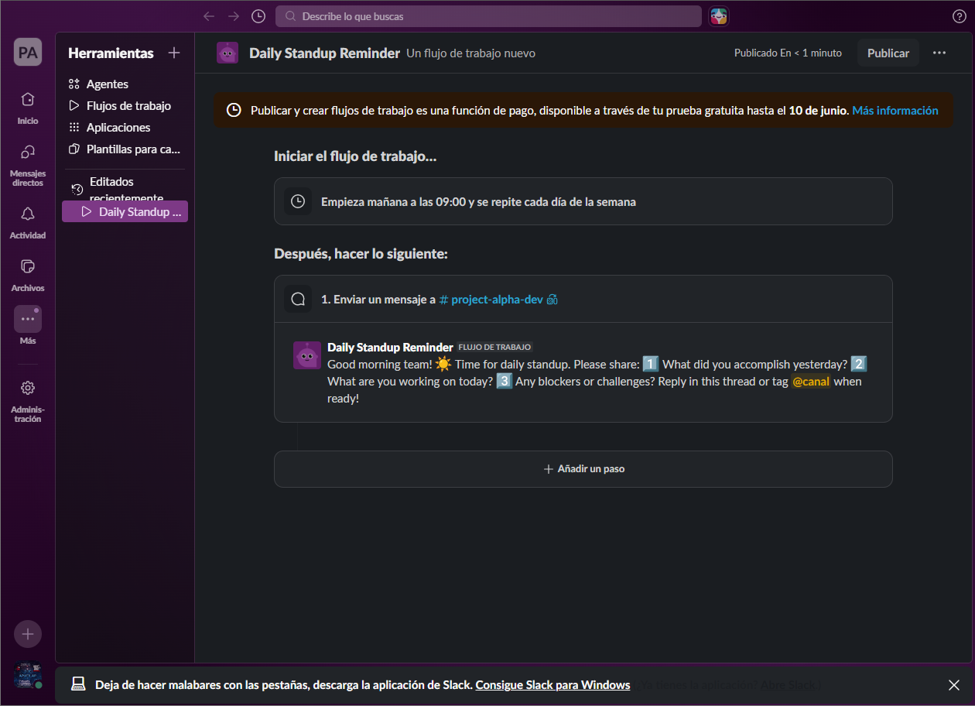
The third task involved the use of Slack's Workflow Builder feature to create an automated daily standup reminder. The Workflow Builder was accessed by navigating to the channel settings or the "Tools" menu and selecting "Workflow Builder." Within the Workflow Builder interface, a new workflow was created from scratch by selecting the scheduled time trigger. The trigger was configured to activate every weekday morning at 9:00 AM. The workflow action was set to post a predefined standup prompt message to the #project-alpha-dev channel, containing standard daily standup questions such as what was accomplished the previous day, what is planned for today, and whether any blockers are present. Once the workflow configuration was complete, it was published and activated. This automation eliminates the need for a manual reminder from the project manager, ensuring that the standup ritual is consistently performed without requiring any individual to remember to initiate it, thereby improving team discipline and communication regularity within the project communication structure. [Figure 4]

Figure 4. Screenshot of the Workflow Builder interface showing the configured "Daily Standup" workflow, including the scheduled trigger set to 9:00 AM on weekdays and the associated channel message action targeting #project-alpha-dev.

3. Summary

3.1 Software Suitability Assessment
Slack demonstrates a high degree of suitability for requirements management and IT project communication tasks. The platform directly addresses the core needs of a Project Manager by providing a centralized, persistent, and searchable communication repository that functions as a single source of truth for all project discussions. Its channel-based architecture allows teams to logically segment communication by topic, project phase, or team function, which mirrors the structured nature of requirements management workflows. The ability to store and retrieve historical decisions and technical specifications through Universal Search ensures that project knowledge is never siloed or lost, which is particularly important in environments where requirements evolve and traceability is essential. Furthermore, the integration of Channel Canvases provides a lightweight, embedded documentation capability that is immediately accessible within the communication context, reducing the friction of switching between separate documentation tools. Overall, Slack is well-suited as the primary communication platform for project teams practicing iterative or agile development methodologies.

3.2 Evaluation of Software Functionality
The functionality set offered by Slack is comprehensive and well-aligned with the demands of professional IT project management. The Must Have features-Persistent Messaging, Threaded Replies, Universal Search, and User Identity Management-are robustly implemented and consistently reliable. Threaded replies in particular represent a significant functional advantage, as they allow complex technical discussions to occur in a contextually isolated space without degrading the signal-to-noise ratio of the main channel. The Workflow Builder, while classified beyond the core feature set, proved to be a powerful tool for automating repetitive communication tasks such as daily standups, effectively reducing managerial overhead. App integrations with tools such as Jira and GitHub further extend Slack's utility by consolidating project signals-such as commit notifications, issue updates, and pull request alerts-directly into the communication environment. The Channel Canvas feature, although a Could Have in the MoSCoW prioritization, proved to be a practical addition for lightweight in-channel documentation. The primary functional limitation observed is the restriction of message history to 90 days under the free plan, which may pose a challenge for long-running projects where traceability of early decisions is important.

3.3 User Interface Evaluation
Slack's user interface is widely regarded as one of the most polished and user-friendly in the enterprise communication tool market, and this assessment was confirmed during the laboratory session. The left-hand navigation sidebar provides clear and immediate access to channels, direct messages, threads, and drafts, minimizing the number of clicks required to reach any given communication context. The channel header clearly displays the topic, description, canvas access, and member count, providing at-a-glance contextual orientation. The message composition area supports rich text formatting, emoji insertion, file attachments, and code block input in an intuitive manner. The Workflow Builder interface, while more complex, employs a visual node-based editor that makes automation accessible to non-technical users without requiring scripting knowledge. Overall, the interface imposes a low cognitive load, which aligns with Slack's documented design philosophy and contributes directly to higher team adoption rates. No significant usability issues were encountered during the exercise, and the onboarding experience for a new workspace was smooth and self-explanatory.

3.4 Evaluation of Other Software Attributes
Beyond its core functionality and interface, several additional attributes of Slack merit consideration in the context of IT project management adoption. With respect to performance, the web and desktop applications exhibited low latency in message delivery and search result retrieval, with no observable degradation during the laboratory session. Regarding accessibility, Slack provides keyboard navigation support, screen reader compatibility, and adjustable text sizes, making it broadly accessible to users with diverse needs. In terms of security, the platform supports LDAP and SSO-based identity management even at lower pricing tiers, and enterprise plans extend this to SAML-based authentication, compliance data exports, and guaranteed 99.99% uptime SLAs, making it viable for regulated industries. The pricing model is competitive: the free tier is functional enough for evaluation and small teams, while the Pro plan at $7.25 per user per month offers a significant capability uplift. One notable limitation is the free tier's 90-day message history cap, which restricts the availability of older project knowledge for teams operating on a budget. Additionally, while Slack's integration ecosystem is extensive, configuring complex automations via the Workflow Builder may require a non-trivial time investment for users unfamiliar with workflow logic. Despite these constraints, Slack remains a leading and well-justified choice for group communication and coordination in IT project management contexts.

